Terms and Their
Relationships
  - Relationships between business terms and their technical implementation

Contents
Preface 3
Customer-Facing Terms 4
Technical Terms 6
Relationships 8
Examples 9
The Simple Example 9
Two Departments in the Same System 10
Two Independent Departments 11

Preface

To make implementation easier for customers, it is important that the terms used in customer communications are the same as those used by the banks. This enables customers to recognize the terminology in materials received from the banks when entering their Bank Connect information in the ERP system.

Customer-Facing Terms
Term | Explanation
Agreement ID | A key is defined to distinguish between different functions or user groups within the same system and for the same customer. It makes it possible to assign different functions and permissions when submitting payments and to retrieve content from different mailboxes.  The length of the Agreement ID differs for each data centre:  Bankdata customer numbers typically contain 13 digits.  BEC customer numbers typically contain 11 digits.  SDC customer numbers typically contain 26 digits.
Bank Connect ID | The same as the Agreement ID.
Certificate | A certificate is created for communication between the customer and the financial institution, also referred to as the customer certificate. It is the combination of keys that enables the system to sign, encrypt, and decrypt content.
ERP System | An ERP or financial system that must be able to communicate with the bank through Bank Connect. It does not have to be a fully integrated system using every function in the solution, but it must at minimum support activation of the solution and certificate renewal.
Function ID | The same as the Agreement ID.
Primary Registration Number | The bank's primary registration number, which must be used when the agreement is activated. Its purpose is to control the exchange of data between the customer and the bank. You can find the primary registration number in the Exchange Agreement from the bank.
Customer | In relation to Bank Connect, the customer is the central entity around which the solution is structured. Agreement IDs, certificates, and the connection itself are associated with the customer. The customer can be compared to a system on the financial institution/data-centre side.
Country Code | The bank's country code, which must be used when the agreement is activated. Together with the primary registration number, the country code controls the exchange of data between the customer and the bank. You can find the country code in the Exchange Agreement from the bank.
FI | Abbreviation for Financial Institution.
Mailbox | In online banking, statements or extracts can be ordered for delivery to a mailbox, from which they can be retrieved by an external system such as Bank Connect. A mailbox is identified by a technical address.
Exchange Agreement | The agreement entered into between the company and the financial institution for exchanging data via Bank Connect is called an Exchange Agreement. It must not be confused with the Agreement ID.
Company | A company is the actual business that is a customer, or represents a customer, of one or more banks offering exchange through Bank Connect. This could be an industrial company or consultancy, but also an accountant who keeps accounts for and must be able to pay invoices on behalf of clients.

Technical Terms

Term | Explanation
SOAP | SOAP stands for “Simple Object Access Protocol” and is a well-defined XML-based protocol for communication over HTTP. The Bank Connect solution uses the SOAP protocol as its web-service framework.
SOAP Request | A client-side request to one of the web services implemented on the server; in other words, a web-service call from client to server.
SOAP Response | The response returned by the server after receiving the client's SOAP request.
The Hub | The Hub is a central component of the Bank Connect solution. It is responsible for forwarding all incoming SOAP requests and is the solution's only operationally critical component. The Hub must run 24/7.
Developer Package (Bank Connect API) | The Developer Package enables software providers to implement and integrate the solution quickly. SOAP requests can be constructed, encrypted, signed, and validated through implemented method calls, abstracting the underlying complexity. The examples are written in Java and C# and therefore support software providers developing the solution in either language.
Endpoint | An endpoint is essentially a URL at which a client can access a web service.
Version | Three versions of the Hub are always available in the production and test environments to support backward compatibility. The current versions can always be found at bankconnect.dk.
Release | A new production version of the Hub containing one or more major corrections. A new release results in a new Hub version and therefore a new endpoint.
WSDL | WSDL stands for “Web Services Description Language”. It describes the implementation of a web service and can be regarded as a contract between the server and client sides defining how they communicate.
ServiceHeader | Part of a Bank Connect SOAP request containing, among other things, information about the customer, the ERP provider, and bank details.
TechnicalAddress | Part of a Bank Connect SOAP request containing, among other things, the sender's IP address and the time at which the request was sent.
ActivationHeader | Part of a Bank Connect SOAP request containing, among other things, information about the customer, the ERP provider, and bank details. It is therefore very similar to ServiceHeader, but is not signed.
CorporateMessage | Part of a Bank Connect SOAP response containing the information requested by the original SOAP request. This part is always encrypted.
PaymentMessage | Part of a Bank Connect SOAP request containing an encrypted ISO 20022 document (payment file).
PaymentResponse | Part of a Bank Connect SOAP response. This is the response to submission of a payment file and may be “OK”, “Accepted”, or “Timed out”.
PKCS #10 | A standardized method for requesting a certificate. Bank Connect uses it to renew certificates.
Clients | Typically, the code examples included with the Developer Package, showing how the security solution can be implemented.
Return Code / Error Code | When a SOAP request fails, the SOAP response contains a return code that provides information about the error. The code is a three-digit number.
Function ID | The same as the Agreement ID.

Relationships

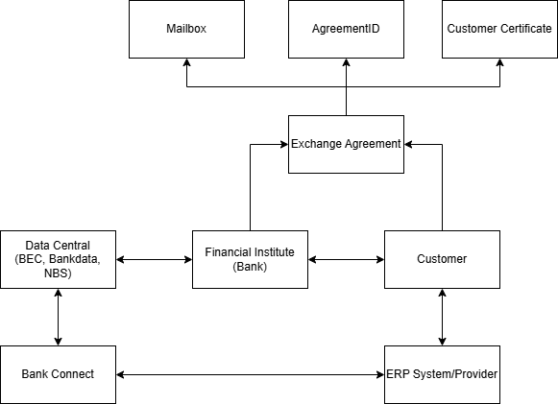

Figure 1 Relationship Model
The model shows how the main Bank Connect entities are connected. A corporate customer may use more than one financial institution and more than one ERP system. The corporate customer is registered as a separate customer with unique information at each financial institution. The same customer may be used by several ERP systems, but a separate Exchange Agreement with the financial institution is required for each ERP system. Each Exchange Agreement has one or more Agreement IDs and normally one certificate. Each Agreement ID is linked to a specific mailbox used to receive statements and extracts. The ERP system uses the customer's certificate and Agreement ID to communicate with the financial institution through Bank Connect.

Examples

The Simple Example
A corporate customer wants to submit payments through Bank Connect. The customer therefore enters into an Exchange Agreement with its financial institution and contacts its ERP system provider to have any required integration module installed in its ERP system.
The financial institution links the customer in its system to the Exchange Agreement and assigns an Agreement ID and a mailbox for delivering statements or extracts to the customer's ERP system.
When the Exchange Agreement is activated, a certificate is generated. The ERP system subsequently uses this certificate to communicate with the financial institution through Bank Connect.
When the customer submits a payment file, the file is sent to the financial institution in encrypted and signed form. Before processing the payments, the financial institution verifies that the customer, Exchange Agreement, Agreement ID, and certificate are correctly associated.
When the customer orders statements or extracts for its ERP system, they are placed in the mailbox and can then be retrieved through a Bank Connect call.

Two Independent Departments
A corporate customer with two independent departments wants to use Bank Connect to communicate with its financial institution. The customer therefore enters into a separate Exchange Agreement for each department's ERP system.
Each Exchange Agreement is assigned its own Agreement ID and mailbox. An activation code must then be issued for each Exchange Agreement so that each ERP system receives its own certificate.
After activation, each ERP system communicates using its own certificate and Agreement ID. Each ERP system also has its own mailbox to which statements or extracts are delivered.
The two ERP systems also submit data independently of each other.
Whether the financial institution's internal systems provide access to the same accounts with the same permissions depends entirely on the agreement between the financial institution and the customer.

